**COMPSCI 345 / SOFTENG 350**

**Tutorial 5: Prototyping**

**Worth 1% of your final grade**

**Tutorial exercises should be undertaken in pairs, to discuss and share ideas**

**Each partner must create their own lo-fi prototype and write in their own words**

**You should plan to spend 50 minutes on this tutorial**

**Upload your completed worksheet to Canvas**

**Due by 6pm on Friday 1 May**

**Aims**

The aim of this assignment is to give you experience in creating a low-fidelity prototype of a single screen, with additional components (i.e., small screen elements, like in the image below).

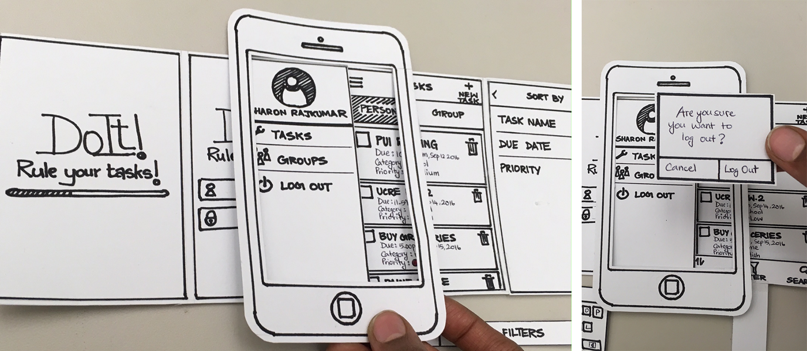

A low-fidelity prototype with additional a small screen element “component”. The component is a pop up box hovering over the screen that asks the user to confirm logout. Photo courtesy of: <https://www.behance.net/gallery/43064215/Power-Paper-Prototyping>

**Background**

Your task is to prototype one “interaction” in a frozen yoghurt smartphone app. Design one low-fidelity screen (and components) to demonstrate one interaction that enables a user to select and add one or more toppings to a frozen yoghurt selection.



Frozen yoghurt with bins of toppings. Author/Copyright holder: [Jonathan Pincas](https://www.flickr.com/photos/saynototheoffice/). Copyright terms and licence: Non-commercial reuse.

We will follow the prototyping approach described in lectures and from the reading of The UX Book chapter 20.

For this tutorial, you will need: paper, a pencil or pen, scissors, a camera (to take photos of the prototypes) and the University of Auckland-recommended, freely available camscanner app.

For this tutorial, students are not allowed to use any digital tools to create the prototype.

**Activity**

Consider this scenario: a user is partway through purchasing a frozen yoghurt, using a dedicated smartphone app for frozen yoghurt orders for takeout/delivery. Imagine that the user has already selected the frozen yoghurt size and flavour. The user is at the stage of selecting toppings, i.e., the user must choose and select which toppings they will add.

In your pair, discuss:

1. how the app should display the range of toppings (on a smartphone screen),
2. how the user should select one or more toppings, and
3. how the app should display that the topping(s) have been added to the order.

Create one low-fidelity screen to show ‘a)’, and annotate the screen to clarify every element on the screen. Include typical elements of real food takeout apps, for example, an app logo and an icon for a shopping cart. Create additional components that show ‘b)’ and ‘c)’. What we mean by components are extra screen elements on pieces of paper, which can be overlaid onto the prototype. These components should show how the actions taken in ‘b)’ and ‘c)’ alter what is on screen.

Describe the user interaction of a), b) and c) in 200 words or less. This section should describe what action the user takes and how the interface responds, for example: “the user touches the box with the word “sprinkles” to select the topping “sprinkles” and a checkmark appears on the box”. This section should also describe how user experience is supported in the prototype design.

Submission: A single PDF document that includes annotated image of the lo-fi screen and components, and the writeup. A photo of the lo-fi screen and components should be scanned by the camscanner app. Bullet points may be used for the writeup.

**Tutorial 5 Worksheet Rubric**

*Criteria*

* Prototype: Quality and user experience of the three different phases of ‘a)’, ‘b)’ and ‘c)’.
* Writeup: Clearly describes the user actions, interface actions, and how they support a good user experience.
* Overall quality: Clarity of writing / prototype / descriptions and professionalism of the presentation.

*Assessment of criteria*

Criteria are assessed as excellent, good, satisfactory, unsatisfactory or fail.

*Submission notes*

Students: it is your responsibility to check the file that you submit. Is it the right file? (Not a blank one, not one from another course). Are images visible?

If there are problems with the file due to students not checking their submission, the late penalty will be applied for resubmission.